IPL Batting Card – Data Analysis Report
This report provides an analysis of the IPL Batting Card dataset. The dataset contains ball-by-ball level batting performance data for players across different matches and innings.

Dataset Overview
The dataset consists of 14 columns representing match details, batsman information, and performance metrics.

Column Description
- - match_id
- - innings
- - team
- - batsman_id
- - batsman_position
- - runs
- - balls
- - fours
- - sixes
- - strikerate
- - isout
- - wickettype
- - fielders
- - bowler_id

Key Observations
1. Runs, balls, fours, and sixes provide quantitative measures of batting performance.
2. Strike rate indicates scoring efficiency of the batsman.
3. The isout column helps identify dismissals, while wickettype and fielders give dismissal details.
4. The dataset can be used to analyze individual player performance, team-wise contributions, and match-level trends.

Analysis

- Filter out all Rows where wiketttype is DNB
Reason: No stats/ data of the batsman to Analysis.

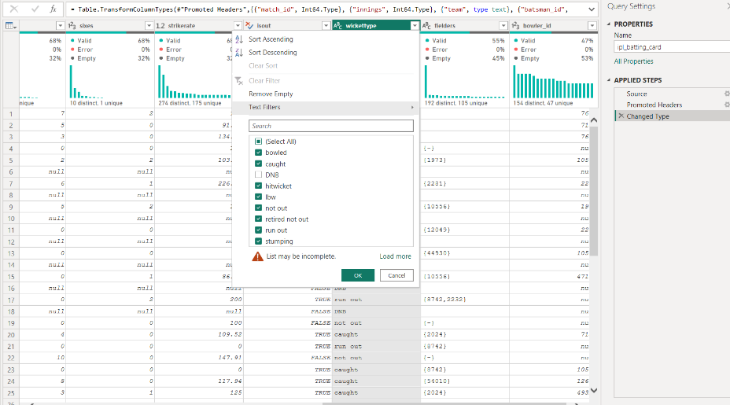

- Replaced fielder column values having ‘ ’ with ‘{-}’
Reason: Since Batsman is wicket is not related to fielder so empty set.

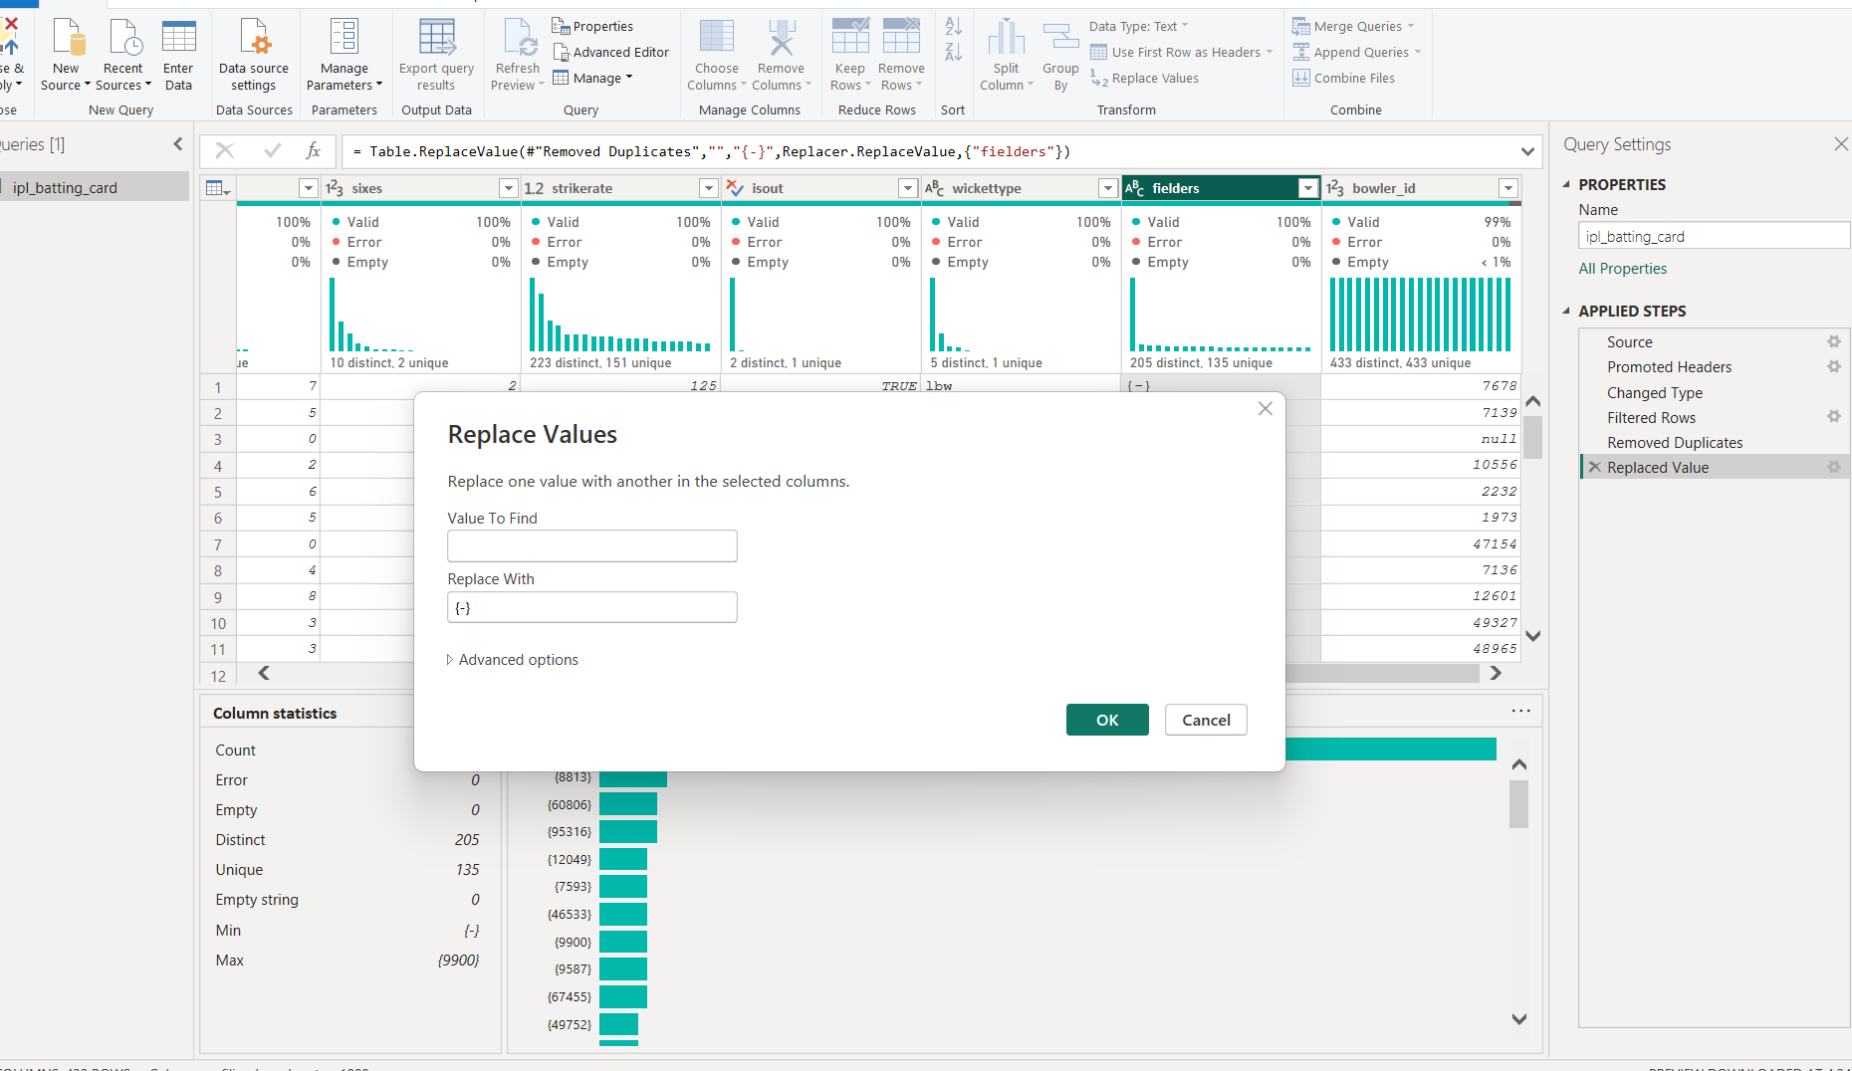

- Replaced Bowler_id values having “null” with 0
Reason: Some Batsman might not have Bowler_id

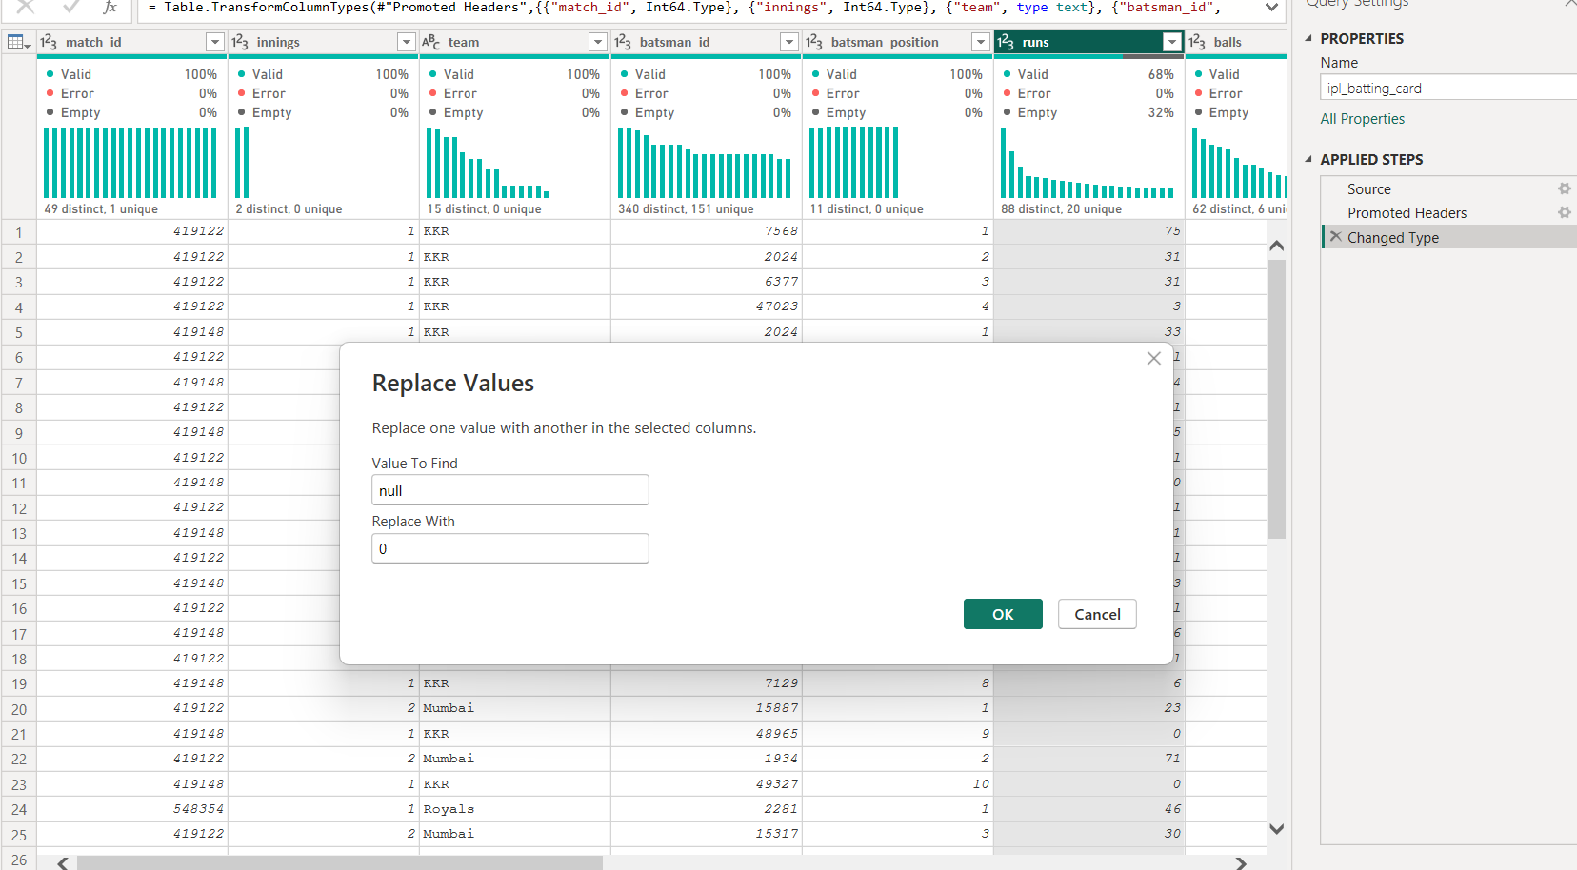

Relationship Analysis:
Before Relationship:
ShipDate was not connected to Calendar, so date-based analysis (year, month, trends) on shipments was not possible.
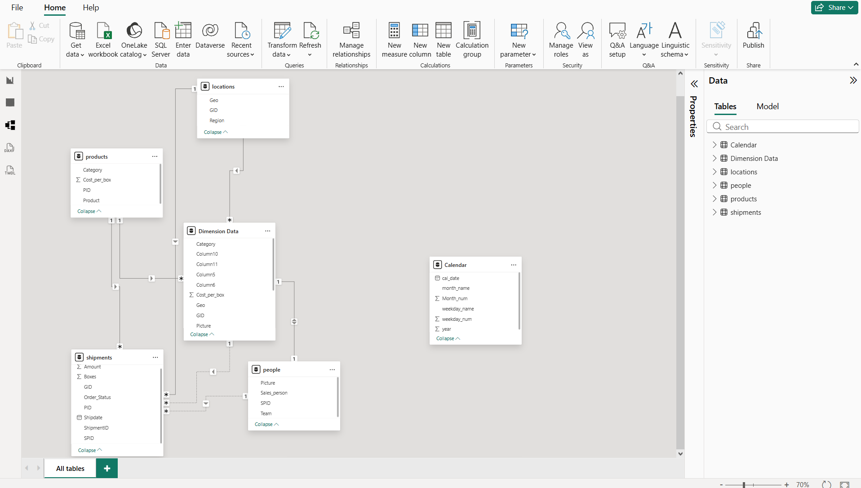
After Relationship:
Creating a relationship between shipments[ShipDate] and Calendar[cal_date] enabled proper time-based analysis, filters, and trends, making the model suitable for reporting and dashboards.
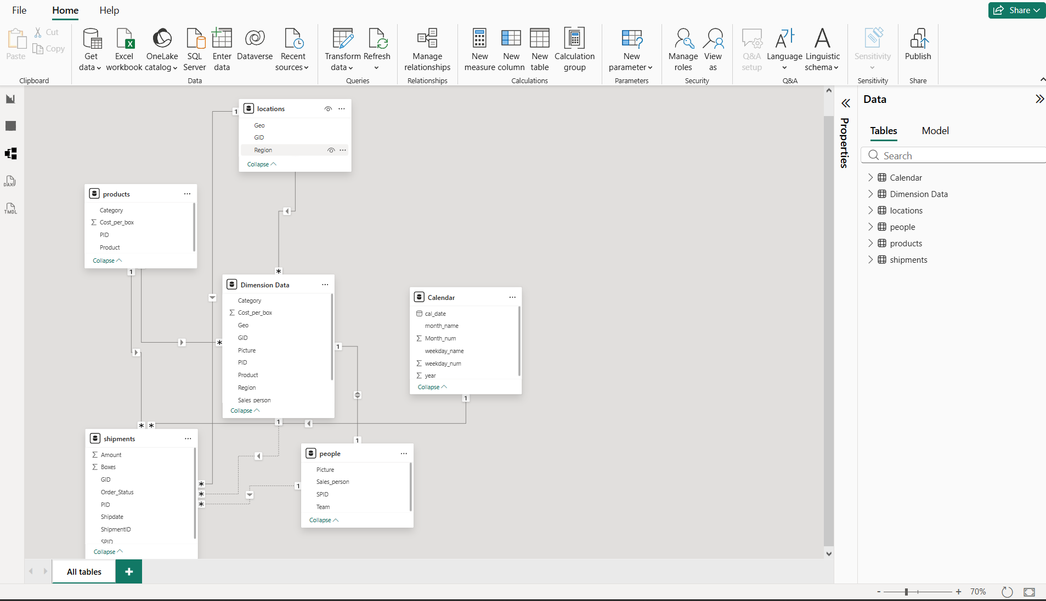

Conclusion
The IPL Batting Card dataset is well-structured and suitable for performance analysis, visualization, and predictive modeling. It can be effectively used in tools like Power BI for dashboards and insights.

